INSTALLATION MANUAL

Requirements:

* Oracle VirtualBox 5.2.6
* Ubuntu Server 16.04 LTS Installer

Steps:

1. Install and launch Oracle VirtualBox 5.2.6. After installation, click “New” to add a virtual machine. Type the name of the new virtual machine.

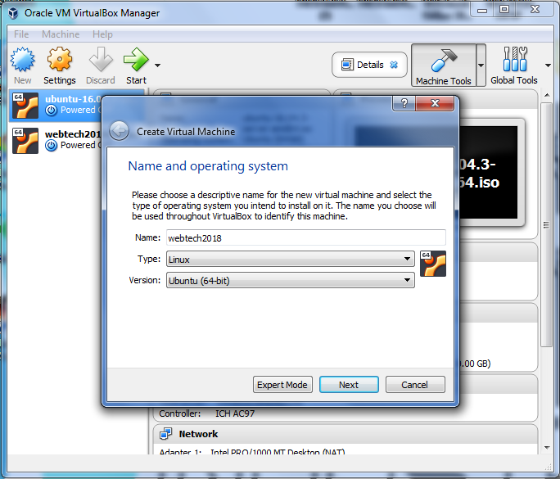

2. Select the amount of memory (RAM) in megabytes, and it is recommended to be at 1024 MB but you may allocate more accordingly.

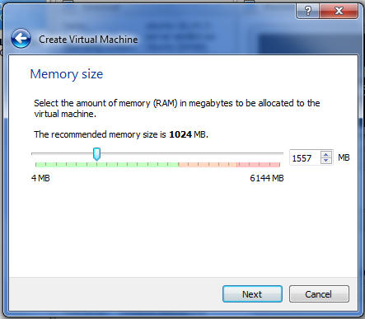

3. For the hard disk, proceed with the default which is ‘create a virtual hard disk’ then click “Create”.

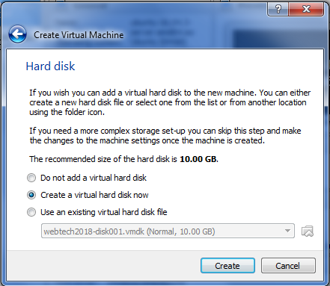

4. Choose the type of file that you would like to use for your new virtual hard disk. Click “Next”

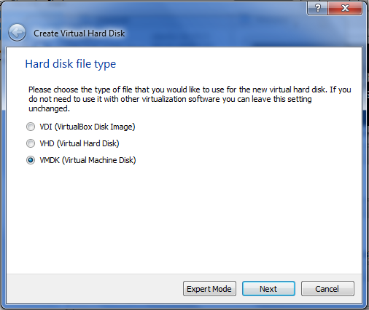

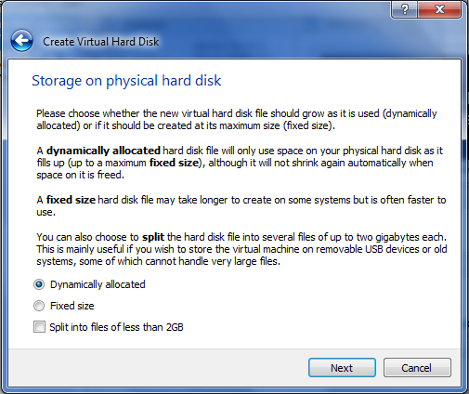5. Choose whether the new virtual hard disk file should grow as it is used (dynamically allocated) or if it should be created at its maximum sixed (fixed size).

6. Next is File location and size, type the new name of the virtual disk file and select the size of the virtual hard disk. In this case

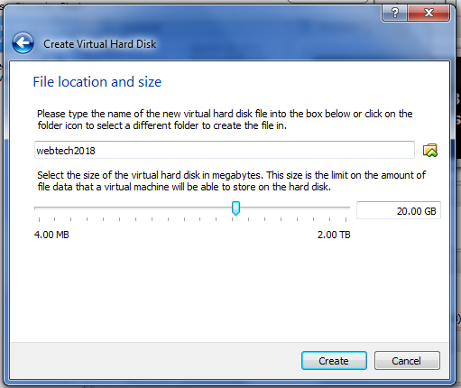

7. Then select a virtual optical disk file or a physical optical drive containing a disk to start your new virtual machine form. Click

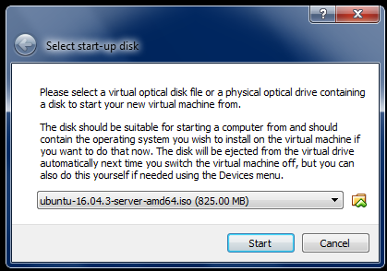

8. Choose your language.

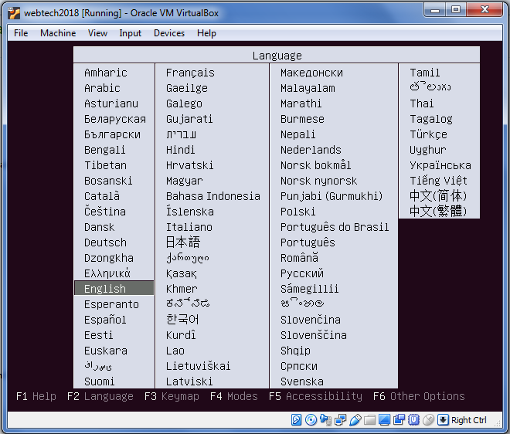

9.Then enter on “Install Ubuntu Server.”



10. Select again the language to be used for the installation process and your country for the time zone.

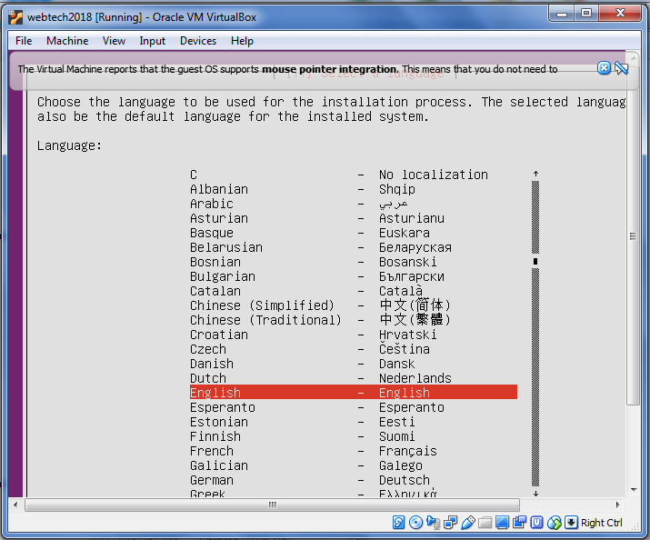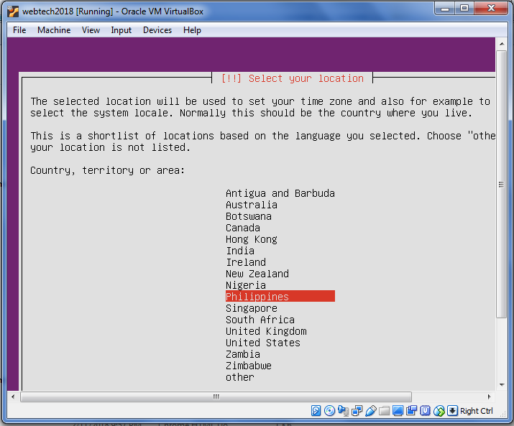

11. Enter your hostname, then continue.

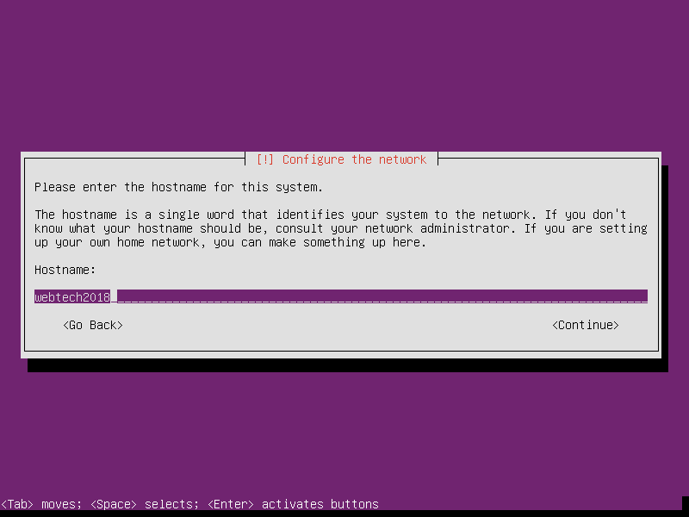

12. Enter the user name, then continue.

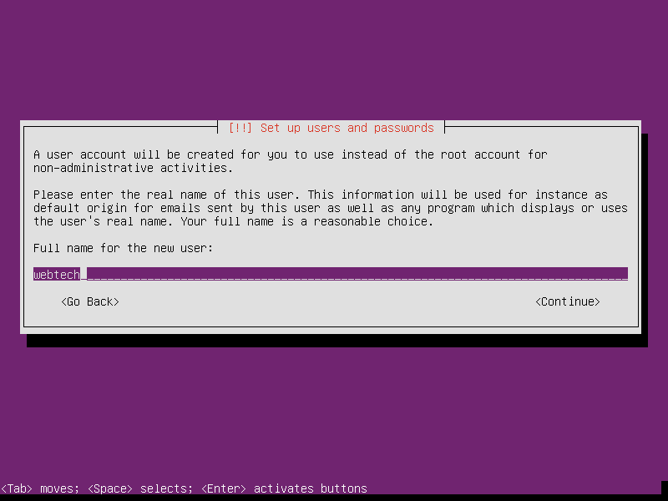

13. Create a username for your account and then continue.

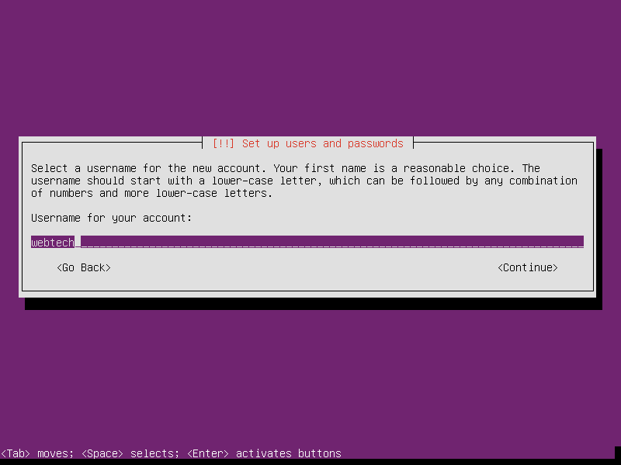

14. Then enter a password for the new user and click continue.

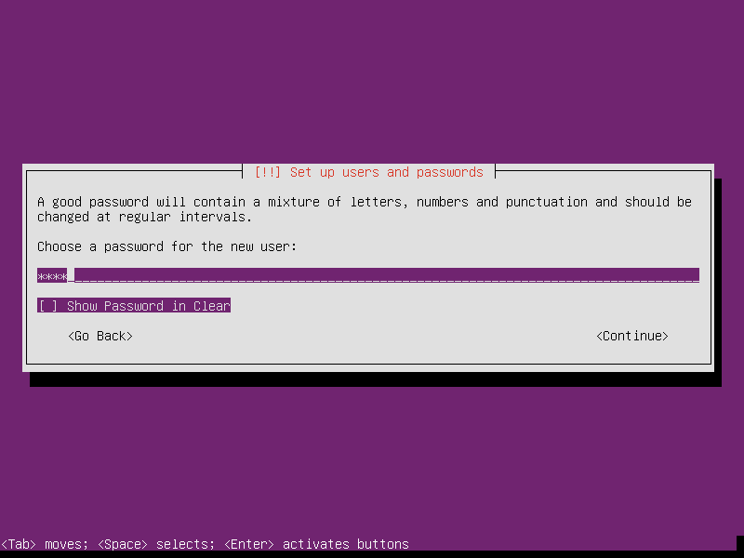

15. Then when it ask you to “encrypt your home directory” enter “no”.



16. Then select a partitioning method. Select “Guided – use entire disk and set up LVM”.

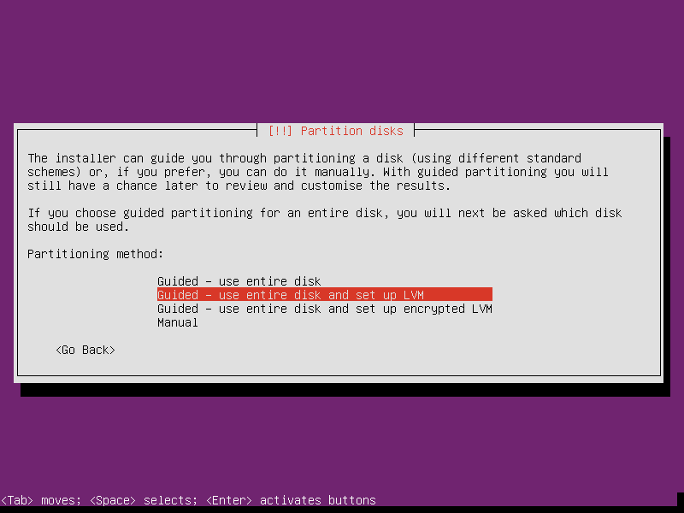  
17. Then select the amount of volume group to be used for the partitioning.In here, “21.0 Gb.” Then select continue.

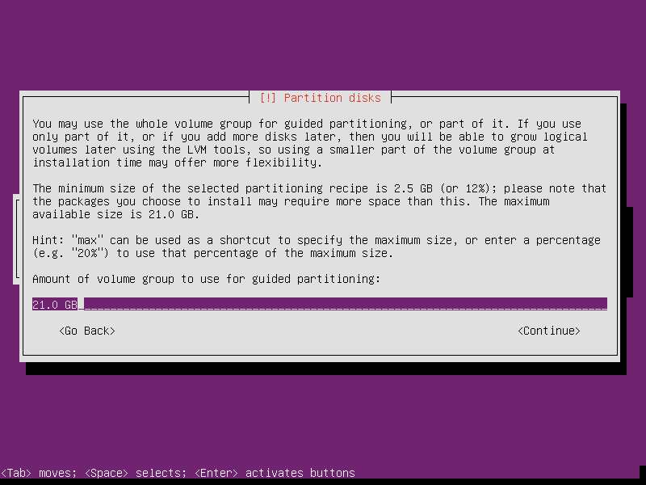

18. Then select “yes” to write the changes to disks.



19. The system will now be installed and you will just wait.



20. Then manage your upgrades on your system. In this case, “No automatic updates”.

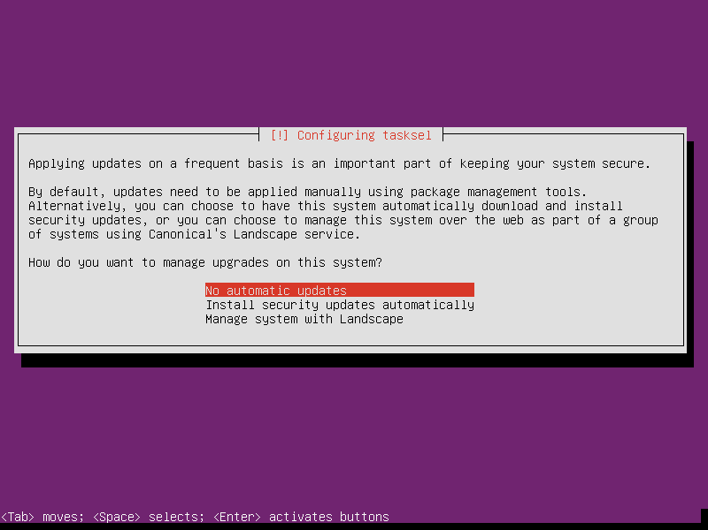

21. Choose the software to install, the standard system utilities is already chosen and for this installation, add OpenSSH server by using the arrow keys to move and the space bar to select. Click “Continue”.

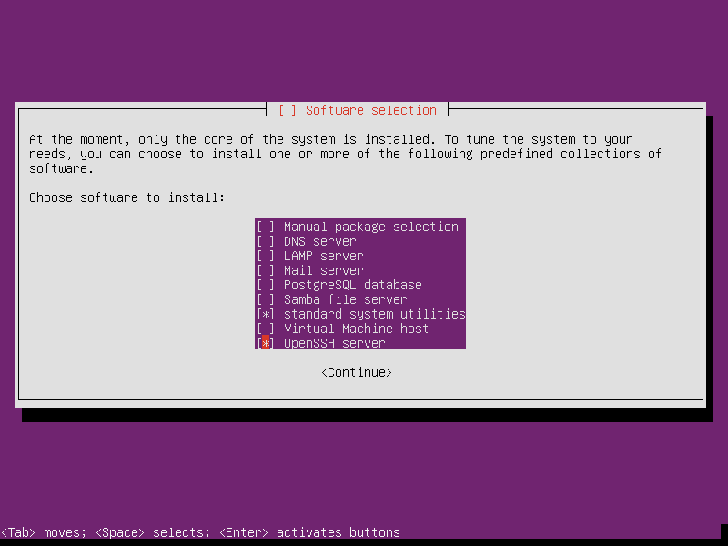

22. Then install the GRUB boot loader on the hard disk by selecting “yes”.

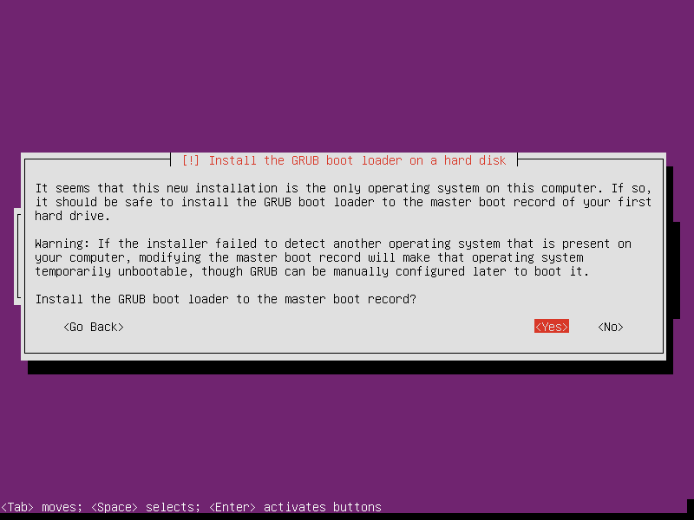

23. Lastly, Finish the Installation and Select Continue.

